Nursery Curriculum Brief – Spring Term 2023
Topics: Super Stories
Around the world

Date | RE | Book of the week - core texts | Maths | Letter of the week | Colours | Science  Weather Chart daily - on-going | PSHE  Living in the wider world
Topic - Super stories
04.01.23 | God made me! | The Gruffalo/The Gruffalo’s Child  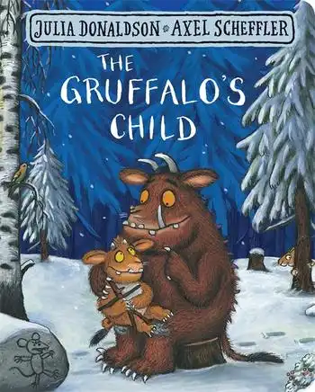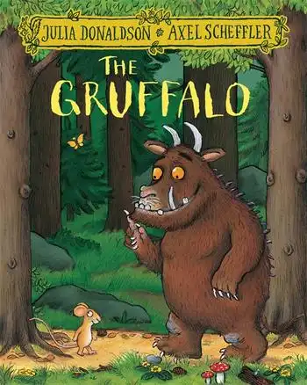 | Number representation.  Develop fast recognition of up to 3 objects, without having to count them individually (‘subitising’). | k | Black | Materials  Textures  -explore collections of natural materials | Who helps us?  Explore different people
09.01.23 | God made a colourful world | The Smartest Giant in Town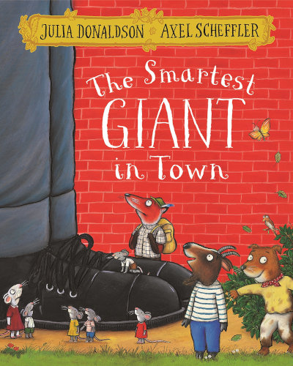 | Recite numbers past 5.  (Nursery Rhymes)  - Say one number for each item in order: 1,2,3,4,5. | u | Blue | Textures  -explore man-made materials | Who helps us in an emergency?  Police/fire brigade/  ambulance
16.01.23 | Being a good friend  Story of the Good Samaritan | The Tiger that Came to Tea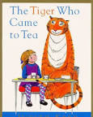 | Know that the last number reached when counting a small set of objects tells you how many there are in total (‘cardinal principle’).  - Show ‘finger numbers’ up to 5. | b | White | Hot and cold  -Observe changes of state
23.01.23  Chinese New Year (22nd) | How did Jesus help people who are ill? | Supertato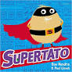 | Link numerals and amounts:  - Show objects to match the numeral, up to 5. | f | Brown | Floating & Sinking  - Exploring different objects | Everyone has different strengths  -discuss as a whole group
30.01.23 | Helping our friends – How did Jesus help others? | Whatever Next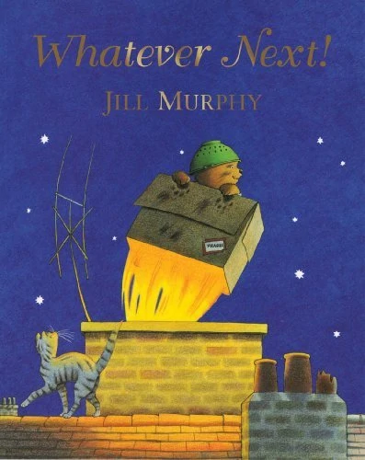 | Recognise numbers to 5. Symbols & mark making.  Compare quantities using language: ‘more than’, ‘fewer than’ | e | Yellow | Seasonal Changes  - observing changes | What is a community  -school  -local area
06.02.23 | Zacchaeus Story | The Jolly Postman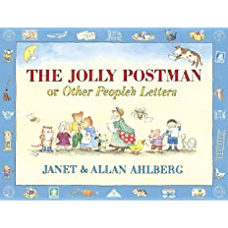 | Make comparisons between objects relating to size, length, weight and capacity. | l | Red | Explore different types of weather  - What should I wear? | Changes in the environment  -what can we do to help?
HALF TERM

Topic - Around the world
20.02.23 | Shrove Tuesday  Ash Wednesday | Australia  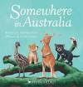  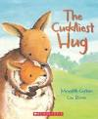 | Talk about and explore 2D shapes  - Use informal and mathematical language: ‘sides’, ‘corners’; ‘straight’, ‘flat’ | h | Green | Forces  Explore magnet & non- magnet | Understanding rules & responsibility.  Why are rules important?  Children to help create their own rules for nursery.  - Display
27.02.23  (World Book Day 2nd March) | Jesus, friend of the children | Africa  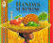  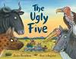 | Exploring shape cont…  - Combine shapes to make new ones – an arch, a bigger triangle, etc  - Select shapes appropriately: flat surfaces for building, a triangular prism for a roof, etc | r | Pink | Explore how things work - wind up toys/cogs
06.03.23 | The miracle of growth and change | America 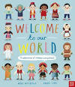 | Counting - numberblocks  Sorting by different criteria number/colour/shape | j | Orange | Push and Pull | Expectations  -Understand that expectations vary depending on different events, social situations and changes in routine.
13.03.23  (British Science Week - 10th-19th) | Peace  Jesus calms a storm | Europe  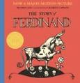  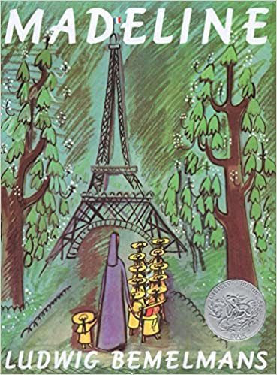 | Ordering Numbers. Some start using language 1 more & 1 less to 5  - Use Numicon  - Duplo towers | v | Purple | Seasonal Changes  -Spring walk in school grounds | Conflict resolution & problem solving - seeing things from another point of view.
20.03.23 | Ramadan | Japan  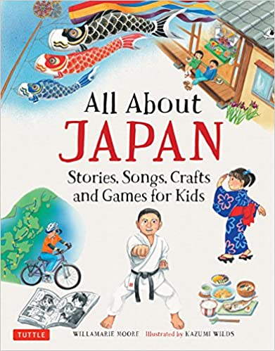 | Patterns  - Talk about the patterns around them. For example: stripes on clothes.  - Extend and create ABAB patterns – stick, leaf, stick, leaf. | Letter Revision | Grey | Growth  -observing changes  - naming spring flowers | Creating opportunities for real choices to support a child's self-confidence
27.03.23 | Easter Story | Canada | Revision 1-5  Subitising to 5 | Letter Revision | Rainbow | New life  -life cycle of a frog | Easter Egg hunt!

